Change Order Request

April 12, 2016

Chinn Construction, LLC
14715 NE 95th Street, Suite 101
Redmond, WA 98052
Attn: Charlie Poggemann

Re: Hadley Apartment Project – Change Order Request

Charlie,

Per Chinn direction, One Way Plumbing will install a gas line to the Skylounge room 613 for an added gas cooktop range. Total cost is $1,719 + 10% OH&P = $1,891. Please let me know if you have any questions or comments. Thank you.

Sincerely,
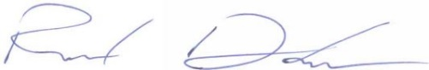
Richard Donelson
Project Manager / Estimator
LEED® Green Associate
richd@owpllc.net
425-591-4296 cell

